- Download desired structures from Research Collaboratory for Structural Bioinformatics Protein Data Bank (RCSB PDB).
- The preferable format for ChimeraX is .pdb files, which in PDB database shows either legacy PDB or Legacy PDB (gz), which are essentially uncompressed and compressed files, respectively. For this project, the uncompressed structure files for MMP-1 and MMP-13 were downloaded.
- The PDB database contains four types of structures including X-ray crystallography, nuclear magnetic resonance (NMR), cryo-Electron Microscopy (EM), and computed structure model (CSM).
- For molecular docking typically high resolution structures are preferred and selected in the following order depending upon availability in PDB: X-ray structures with resolution < 2.5 Å and R-free value of ≤ 2.5; cryo-EM structures with resolution of ≤ 3.0 Å; NMR structures; finally, CSM structures.
- PDB have three R-values (real space) including R-free, R-work, and R-observed which determines the reliability of structure is basically how well the experimental data matches the structure model. Typically, the three values should be in close approximation.
- Select structures preferably co-crystallized with ligands because it helps in identifying the catalytic site.
- For selecting reliable CSM, predicted structures from different databases including SWISS-MODEL, AlphaFold (Deep Mind), or EMSfold can be analyzed.
- For this project human MMP-1 and MMP-13 structures were downloaded from PDB database.
- MMP-1 (966C| pdb_0000966c): Lovejoy et al. 1998; X-ray; Resolution of 1.9 Å; RV-free of 0.33, RV-work of 0.218, and RV-observed of 0.218; Expressed in E. coli; Chain A; Sequence 108-258 aa; Size 469 aa; Molecular weight of 54 kDa; Ca and Zn ion binding sites; Co crystallized with hydroxamic acid inhibitory ligand.
- MMP-13 (3KRY | pdb_00003kry): (Kiefer et al., 2009); X-ray structure; Resolution of 1.9 Å; RV-free of 0.256, RV-work of 0.206, and RV-observed of 0.209; Expressed in E. coli; chain A; 471 aa; Molecular weight of 54-60 kDa; 1-(2-methoxyethyl)-N-oxo-4-({4-[4-(trifluoromethoxy)phenoxy]phenyl}sulfonyl)piperidine-4-carboxamide inhibitory ligand.
- Table showing the amino acid number involved in binding to ions and ligand. It also shows the secondary structures such as α-helix and β-sheets.
Protein | α-helix | β-sheet | Ca | Zn | Ligand
MMP-1  (108-258 aa) | 20-37  105-116 143-153 | 6-12  41-44  52-57  75-77  105-116 143-153 | 17-94 | 61-121 | 73-134 (RS2)
MMP-13  (1-164 aa) | 27-43  113-126  152-164 | 14-19  49-53  60-65  83-85  96-99  111-112  127-128 | 59-205 | 69-129 | 80-144 (3KR)

- The structures were verified for ligand, ions, and water molecules. The images below exhibit the observations for MMP-13 protein.

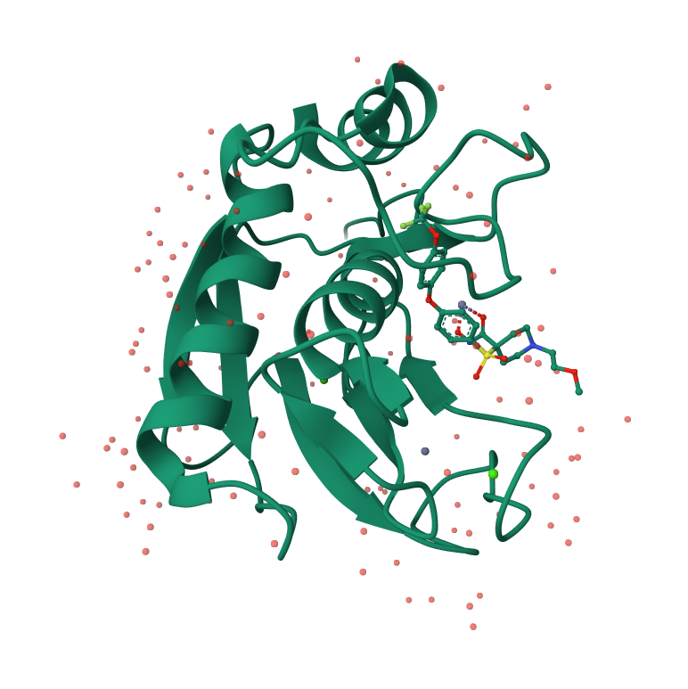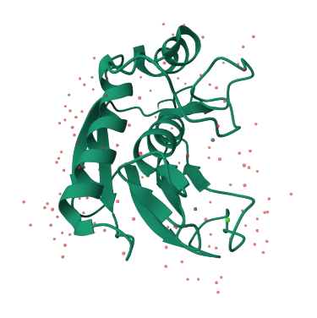
Water (red), ligand (ball & stick), Ions Ca (green) & Zn (grey) Water (red), No ligand, Ca (green) & Zn (grey)

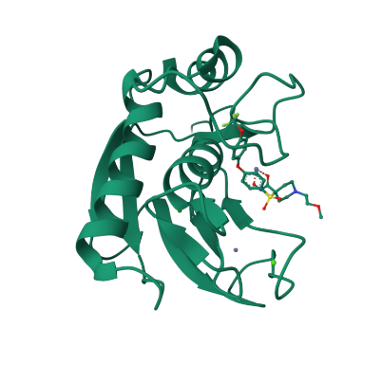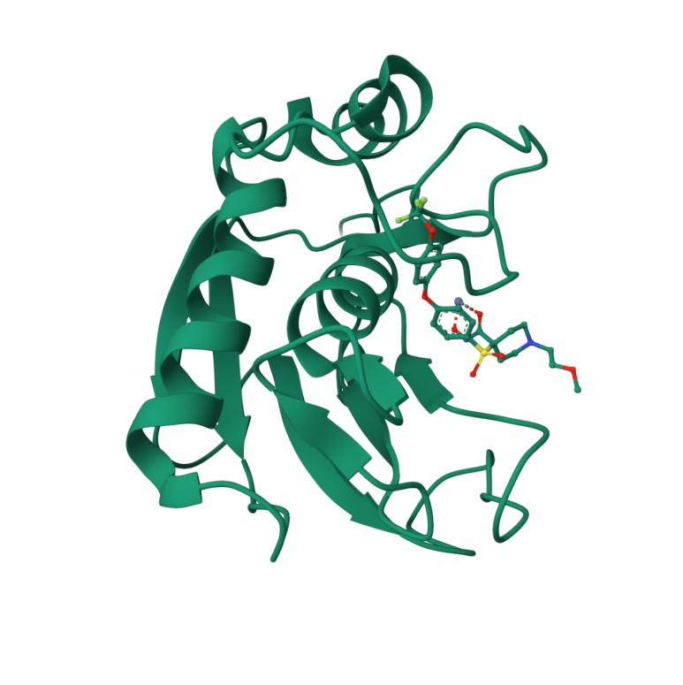
No water, With Ligand, Ca (green) & Zn (grey) No water & ions, Ligand (ball & stick)

